The seashore is a great place to explore and build sandcastles!
Seashore Monster Sandcastle

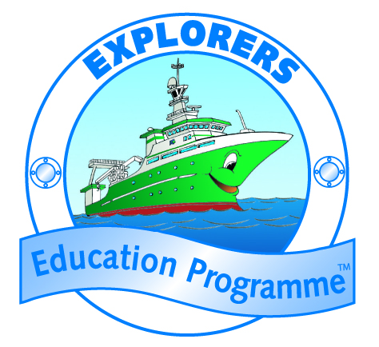
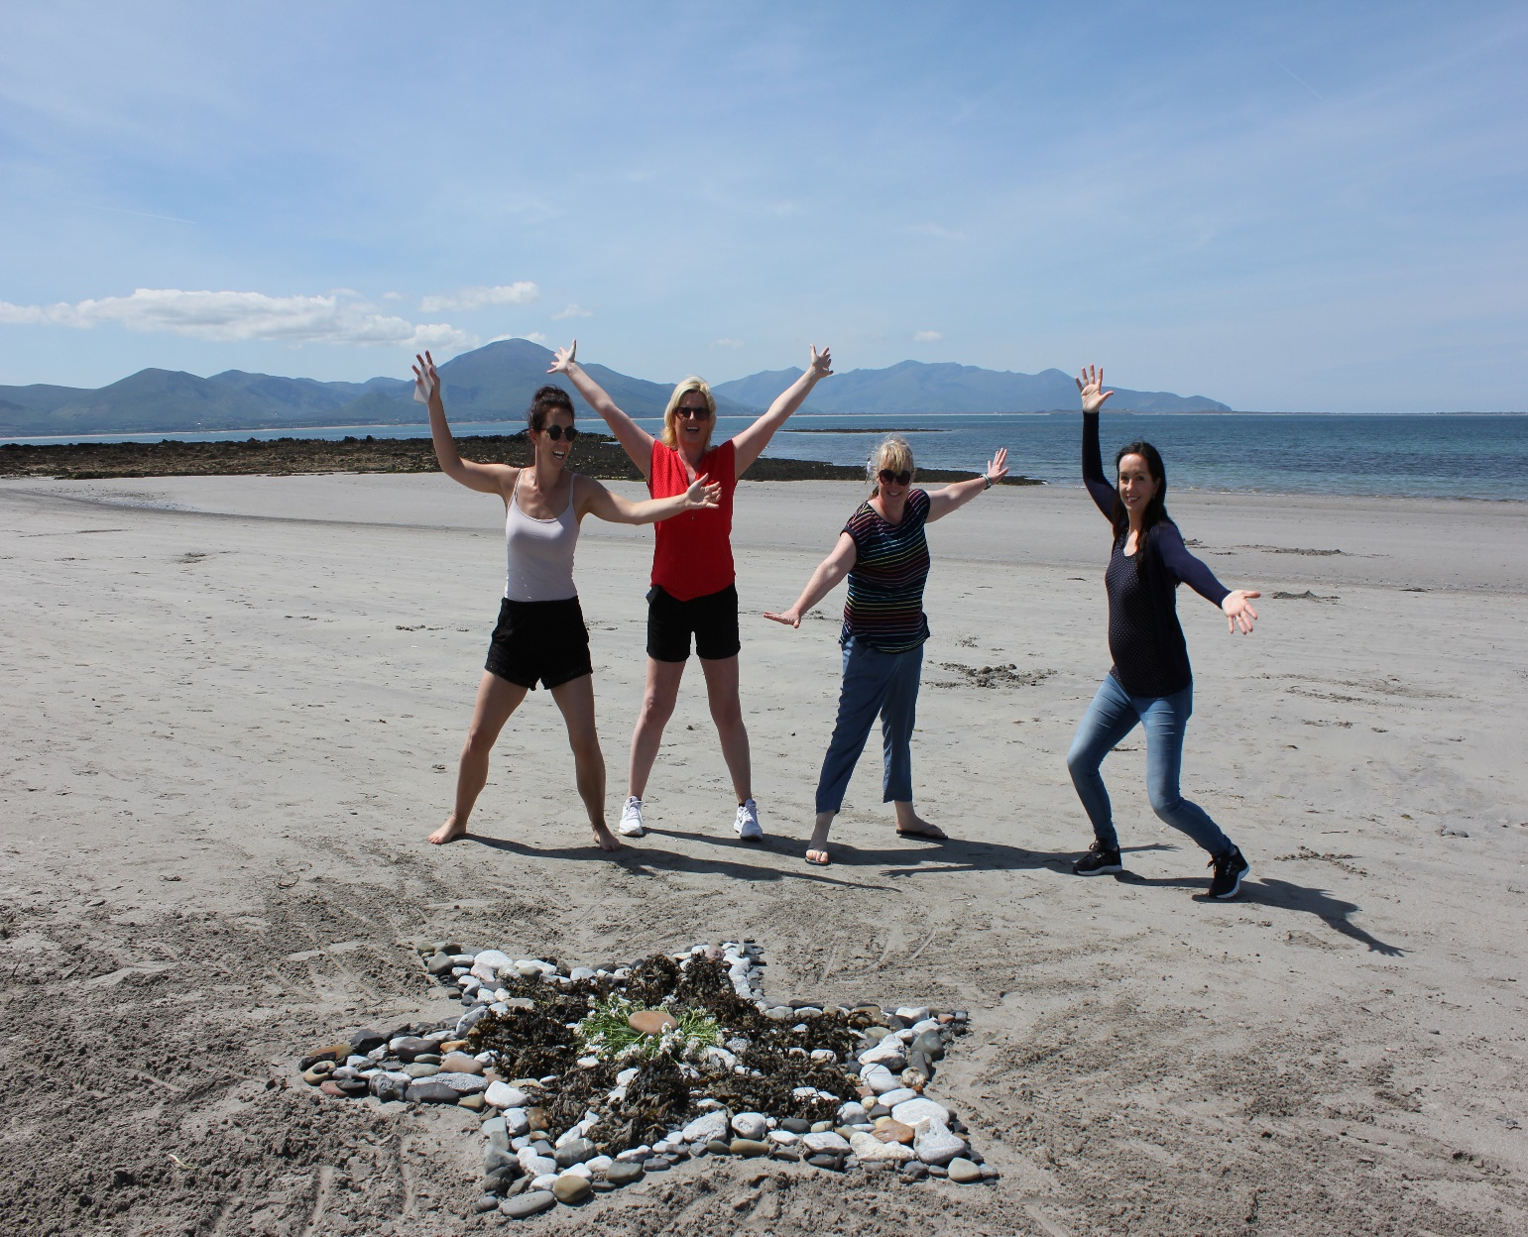
Once you have completed exploring the shore and rockpools, get the children to move up to the sandy part of the beach. On your way back up the shore, complete a mini-beach clean and find some clean and safe ‘treasure’ for building a monster sandcastle (plastics, rope, bottles etc) . Also try finding lots of amazing shells, feathers, flotsam and jetsam, seaweeds, stones and more.
Set a place on the shore and time limit for the Sea Monster building.
Encourage the children to build the highest and / or largest monster sandcastle based on their favourite animal they found on the seashore. Instruct the children that they can only use the items they have found on the beach to add to the monster. You may want to give them extra time to find additional items.
After creating the sea monster, take a photo of the children with their monster. Get the children to share a story or information about their monster:
- Describe the animal or monster
- What is its name?
- Do they know the species name in Irish?
- Where does the creatures like to live?
- How big does the monster get when it is an adult?
- What it likes to eat?
With the instruction to build the largest or highest sea monster, discuss with the children how they can measure the monster?
- Encourage the children to think of innovative ways to measure the size and height. You might get the children to stand next to the monster – how tall are they compared to the monster sandcastle?
- Can you get the children to lie next to their sea monster to compare the length or width of the monster sandcastle.
Remember, when heading home put the rubbish and items (that don’t belong on the shore) in the bin near the shore. Alternatively take the rubbish home to be reused in seashore arts and crafts, recycled or discarded safely.

